1. **List containing int, String and double**

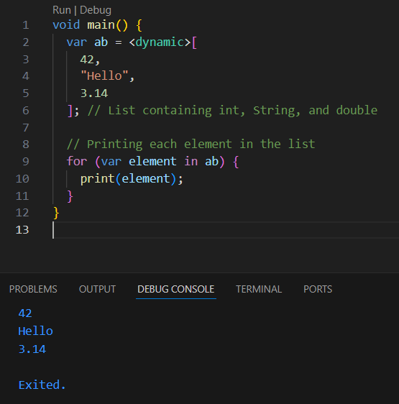

* **Create a list**: ab contains mixed data types (int, String, double).
* **Loop through the list**: The for-in loop prints each element.

2**,Printing the length of the list**

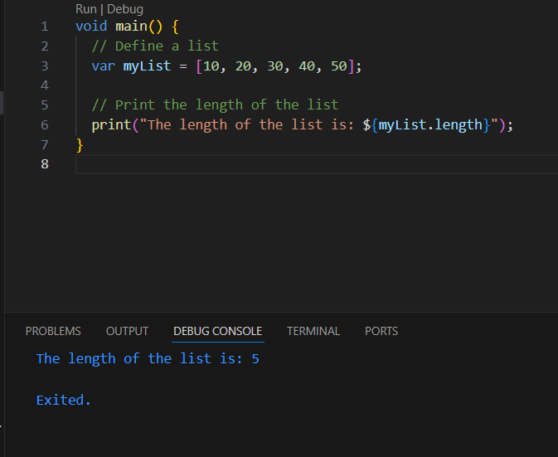

* **Define a list**:  
  myList is a list containing integers [10, 20, 30, 40, 50, 89].
* **Get and print length**:  
  myList.length gets the number of elements in the list, which is printed using print().

3,**Nested list**

A **nested list** in Dart is a list that contains other lists as its elements. It allows you to create multi-dimensional data structures, such as a 2D or 3D list.

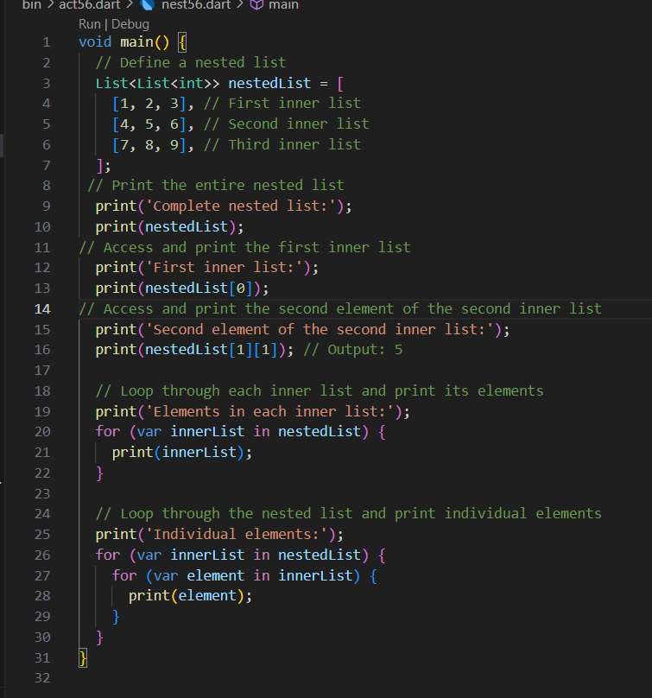

* **Define a nested list**:  
  1,A 2D list nestedList contains three inner lists.
* **Print entire list**:

1,Prints the full nestedList.

* **Access specific data**:

1,Print the first inner list using nestedList[0].

2,Print the second element of the second inner list using nestedList[1][1].

* **Loop and print**:

1,Print each inner list.

2,Print each individual element using nested loops.

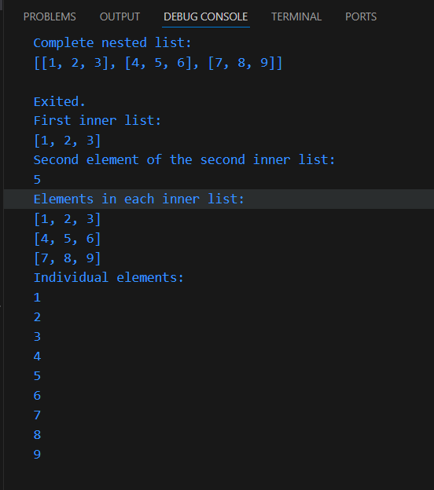

4, **Adding and removing values in list, if conditions, nested list**

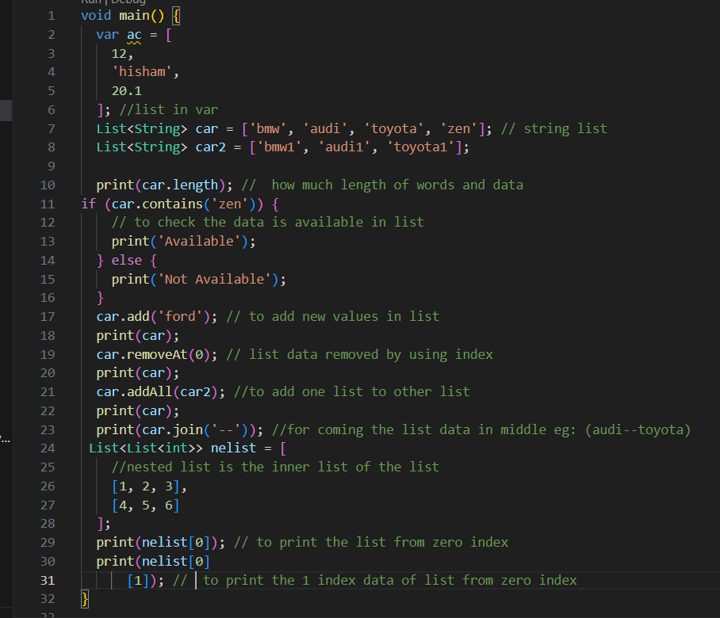

* **List Definition**:
* ac: A list containing mixed data types (int, String, double).
* car and car2: Lists containing car names (strings).
* **Length of List**:
* car.length: Prints the number of elements in the car list.
* **Check if Item Exists**:
* car.contains('zen'): Checks if 'zen' is in the car list. It prints Available if true, otherwise Not Available.
* **Modify List**:
* car.add('ford'): Adds 'ford' to the car list.
* car.removeAt(0): Removes the item at index 0 from the car list.
* car.addAll(car2): Adds all elements of car2 to car.
* car.join('--'): Joins the elements of car into a single string, separated by '--'.
* **Nested List**:
* nelist: A 2D list with two inner lists.
* nelist[0]: Prints the first inner list.
* nelist[0][1]: Prints the second item of the first inner list.

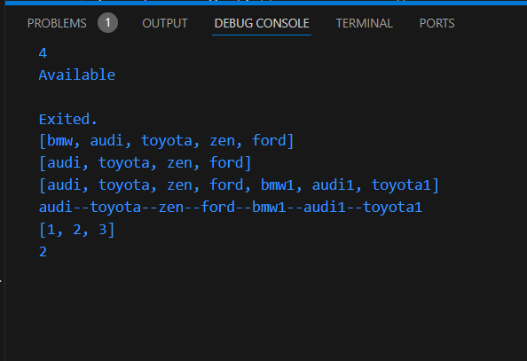

5, Map

To print the key and value separately and together from a Map

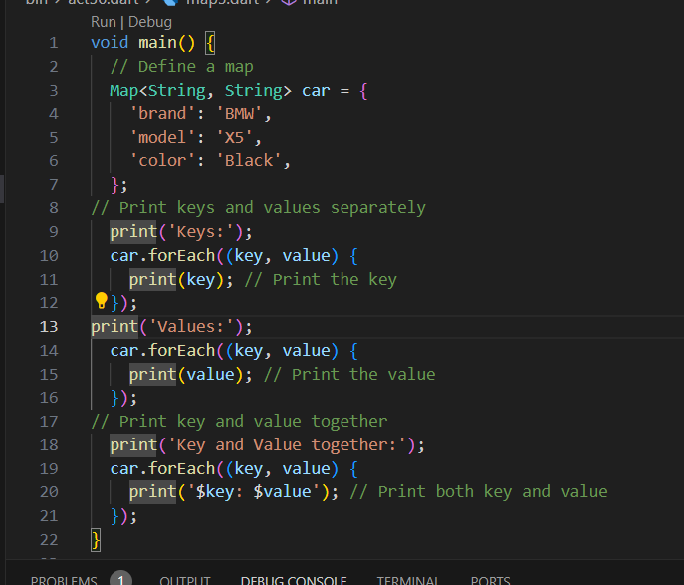

* **Map Definition**:  
  A Map named car stores car details with keys like 'brand', 'model', and 'color'.
* **Print Keys**:  
  Loop through the map and print each **key** (e.g., 'brand', 'model').
* **Print Values**:  
  Loop through the map and print each **value** (e.g., 'BMW', 'X5').
* **Print Key and Value Together**:  
  Loop through the map and print each **key and value** together (e.g., 'brand: BMW').

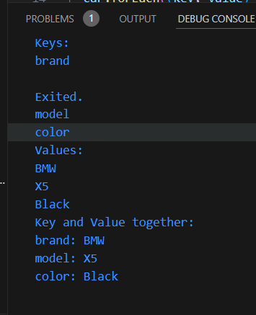

6,Set in dart

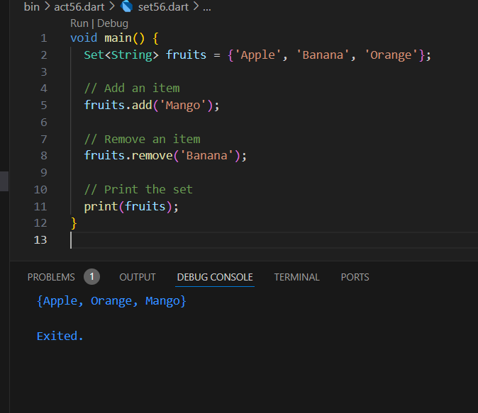

* **Create a Set**: A Set of fruits is created with 'Apple', 'Banana', and 'Orange'.
* **Add**: 'Mango' is added to the set.
* **Remove**: 'Banana' is removed from the set.
* **Print**: The set is printed.